**[Number of Nodes in the Sub-Tree With the Same Label](https://leetcode.com/problems/number-of-nodes-in-the-sub-tree-with-the-same-label/description/)**

*You are given a tree (i.e. a connected, undirected graph that has no cycles) consisting of n nodes numbered from 0 to n - 1 and exactly n - 1 edges. The****root****of the tree is the node 0, and each node of the tree has****a label****which is a lower-case character given in the string labels (i.e. The node with the number i has the label labels[i]).*

*The edges array is given on the form edges[i] = [ai, bi], which means there is an edge between nodes ai and bi in the tree.*

*Return an array of size n where ans[i] is the number of nodes in the subtree of the ith node which have the same label as node i.*

*A subtree of a tree T is the tree consisting of a node in T and all of its descendant nodes.*

***Example 1:***

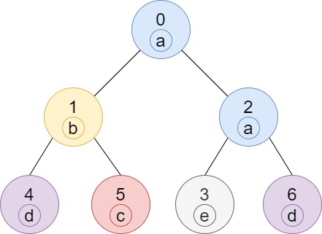

***Input:*** *n = 7, edges = [[0,1],[0,2],[1,4],[1,5],[2,3],[2,6]], labels = "abaedcd"*

***Output:*** *[2,1,1,1,1,1,1]*

***Explanation:*** *Node 0 has label 'a' and its sub-tree has node 2 with label 'a' as well, thus the answer is 2. Notice that any node is part of its sub-tree.*

*Node 1 has a label 'b'. The sub-tree of node 1 contains nodes 1,4 and 5, as nodes 4 and 5 have different labels than node 1, the answer is just 1 (the node itself).*

***Example 2:***

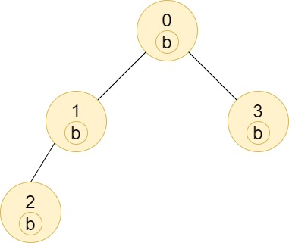

***Input:*** *n = 4, edges = [[0,1],[1,2],[0,3]], labels = "bbbb"*

***Output:*** *[4,2,1,1]*

***Explanation:*** *The sub-tree of node 2 contains only node 2, so the answer is 1.*

*The sub-tree of node 3 contains only node 3, so the answer is 1.*

*The sub-tree of node 1 contains nodes 1 and 2, both have label 'b', thus the answer is 2.*

*The sub-tree of node 0 contains nodes 0, 1, 2 and 3, all with label 'b', thus the answer is 4.*

***Example 3:***

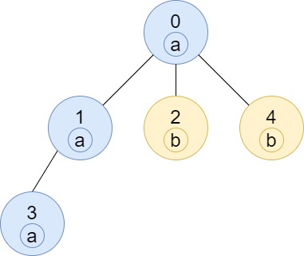

***Input:*** *n = 5, edges = [[0,1],[0,2],[1,3],[0,4]], labels = "aabab"*

***Output:*** *[3,2,1,1,1]*

***Constraints:***

* *1 <= n <= 105*
* *edges.length == n - 1*
* *edges[i].length == 2*
* *0 <= ai, bi < n*
* *ai != bi*
* *labels.length == n*
* *labels is consisting of only of lowercase English letters.*